Study Sheet for the Wetlands
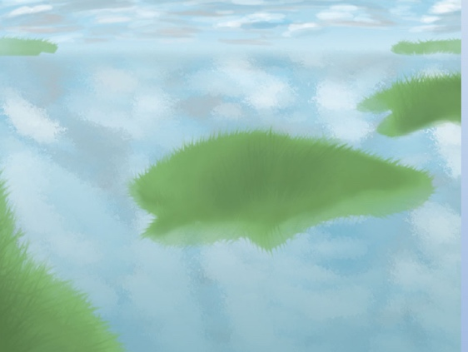
Fun Facts
1. A wetland is a place in which the land is covered by water.
2. Wetlands are the barrier between land and water.
3. The wetlands include swamps, bogs, and marshes.
4. Wetlands consist of any body of water that stands still and lies low.
5. Wetlands can be made of freshwater, saltwater, or a combination of the two.
6. Amphibians, birds and many different insects are the main animals in wetlands.
7. A swamp is a wetland that contains trees like a forest.
8. Wetlands are responsible for keeping rivers at a normal level.

Animals: pelicans, herons, ducks, geese, swans, frogs, platypus, swamp rat, turtles, snakes, skinks, alligators, newts

Plants: shrubs, cattails, reeds, grasses, cypress trees

