Study Sheet for the Grasslands –Savannah
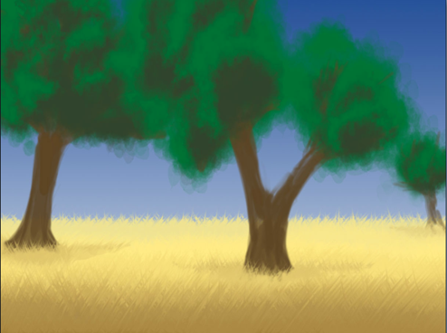
Fun Facts
1. The savanna is an area that has a very dry season and then a very wet season.
2. Savannas are located in Africa, South America, India, and Australia.
3. Almost half of Africa is considered a savanna.
4. There are often large herds of grazing animals on the savanna that thrive on the abundance of grass and trees.
5. Many of the animals in the savanna have long legs which helps them when migrating long distances.
6. Fires are an important part of the savanna.
7. The savanna stays pretty warm for most of the year.

Animals: zebras, wildebeests, elephants, giraffes, ostriches, gazelles, buffalo, lions, hyenas, cheetahs, leopards, black mambas, and wild dogs.

Plants: grasses, acaia tree, baobob tree

