Study Sheet for the Rainforest
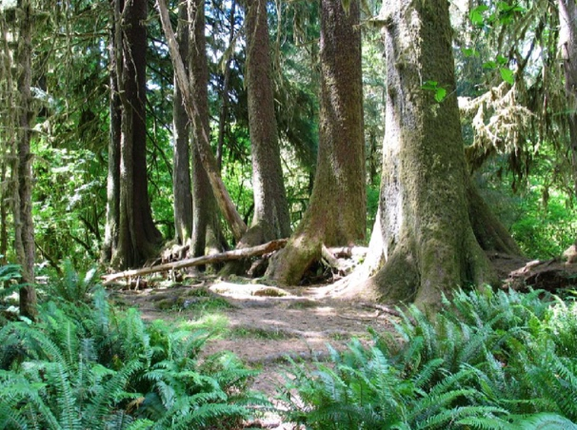
Fun Facts
1. Rainforests are forests that receive high amount of rainfall.
2. Rainforests help to maintain our supply of drinking water and fresh water
3. About 1/4 of natural medicines have been discovered in rainforests.
4. The average temperature of the tropical rainforest remains between 70 and 85° F.
5. Insects make up the majority of living creatures in the tropical rainforest.
6. More than 56,000 square miles of the rainforest are lost each year.
7. Giant bamboo plants can grow up to 9 inches a day.
8. The trees rainforest grow so close that rain falling can take as long as 10 minutes to reach the ground.
.
Animals: snakes, birds, frogs, insects, cougars, chamelions, turtles, jaguars, poison dart frogs

Plants: pine trees, bamboo, orchids, palm trees, rubber trees, orchids, water lilies, figs, banana tree

