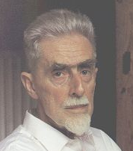 | M.C. Escher  Learning Peninsula 5-b
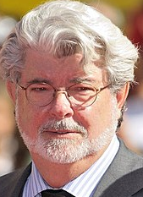 | George Lucas  Learning Peninsula 5-a

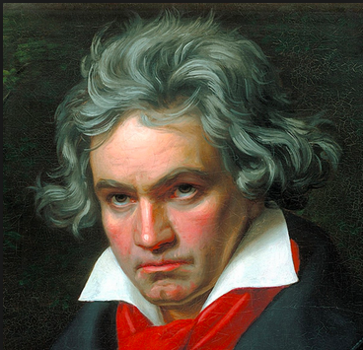 | Ludwig Van Beethoven  Learning Peninsula 5-c

