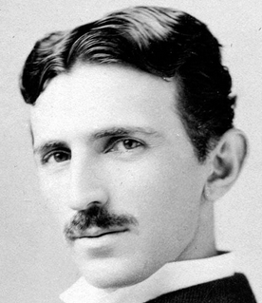 | Nikola Tesla  Learning Peninsula 4-a

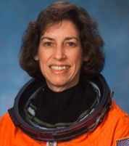 | Ellen Ochoa  Learning Peninsula 4-b

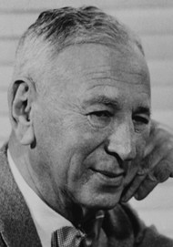 | Rube Goldberg  Learning Peninsula 4-c

