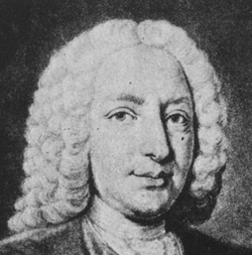 | Daniel Bemoulli  Learning Peninsula 3-a

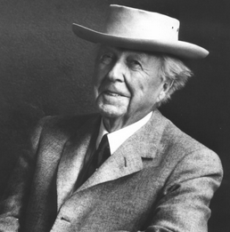 | Frank Lloyd Wright  Learning Peninsula 3-b

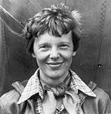 | Amelia Earhart  Learning Peninsula 3-c

