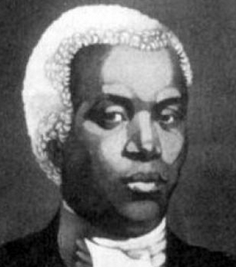 | Benjamin Banneker  Learning Peninsula 2-a

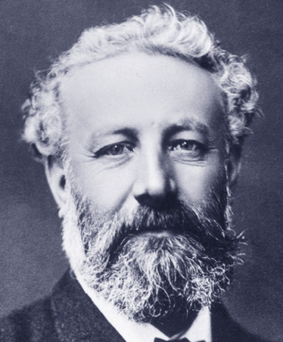 | Jules Verne  Learning Peninsula 2-b

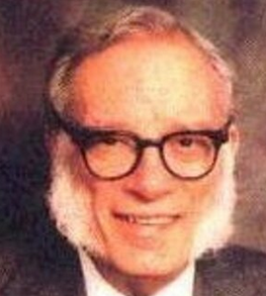 | Isaac Asimov  Learning Peninsula 2-c

