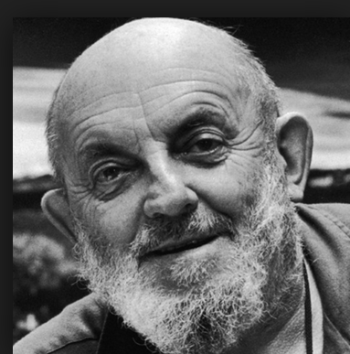 | Ansel Adams  Learning Peninsula 1-b
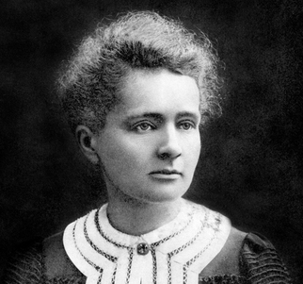 | Madame Maria Curie  Learning Peninsula 1-a

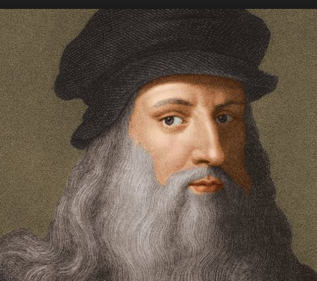 | Leonardo Da Vinci  Learning Peninsula 1-c

