Study Sheet for the Forest
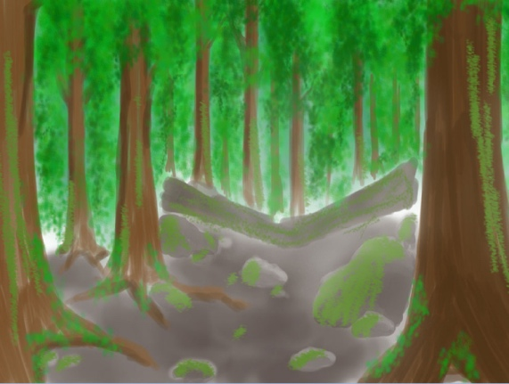
Fun Facts
1. More animals live in our forests than anywhere on Earth.
2. The forest is home to over half of the world’s plant and animals.
3. Around 2000 trees are removed from our forests every day.
4. Temperate forests are those in regions that are neither too hot or too cold.
5. During the winter time some of the animals in boreal forests hibernate.
6. Forests are populated by trees that create canopies of different heights.
- 7. Some common trees found in these forests are maple, beech and oak.

Animals: black bears, mountain lions, deer, fox, squirrels, skunks, rabbits, porcupines, timber wolves, mountain lions, squirrels, hawks, eagles

Plants: trees, flowers, bushes

