S.T.E.A.M.
EXPECTATIONS

Be responsible.
Keep food & drink out of the lab.
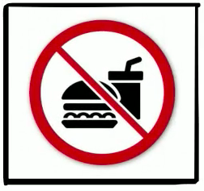

Use good citizenship.

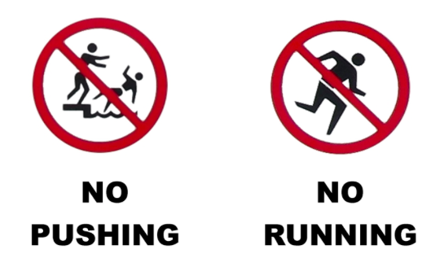

Be trustworthy.
Only print with permission.
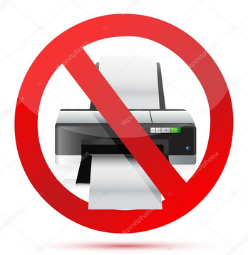

Be respectful.
Clean your work area & put materials away.

