Study Sheet for the Desert
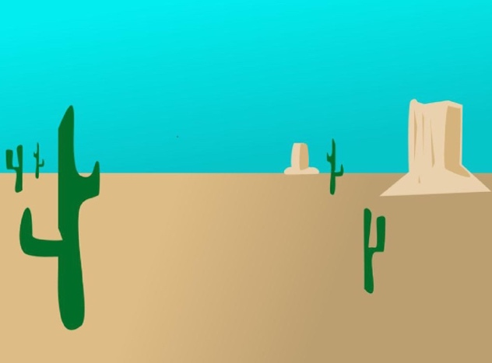
Fun Facts
- Deserts generally receive less than 16in. of rain a year.
- Around one third of the Earth's surface is covered in deserts.
- The original meaning of the word desert is 'an abandoned place'.
- Hot deserts usually feature high temperatures in the daytime and cold temperatures at night.
- With lack of water, high daytime temperatures and sometimes freezing conditions at night, deserts can be extremely dangerous places for humans.
- Deserts are home to a range of well suited plant life including various shrubs and cacti.
- Deserts are home to animals such as lizards and coyote.

Animals: lizards, coyotes, scorpion, snakes, toads

Plants: cactus, shrubs

