Copy and Paste Activity
Text: To copy and paste text from a document or webpage.
1. Highlight the text you want to copy.
2. Press and hold your Command key and press the “C”.
3. Place your cursor where you want to put the text.
4. Press and hold your Command key and press the “V” key. Complete the table below to using these methods.
Blue | Green | Red

Pictures: To copy and paste pictures from a document or webpage,
1. Select the picture you want to copy.
2. Press and hold your Command key and press the “C”.
3. Place your cursor where you want to put the picture.
4. Press and hold your Command key and press the “V” key.
Complete the table below to using these methods.
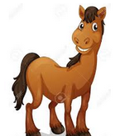

 | Bird |  |  | Fish
 | Dog |  |  | Horse

