Study Sheet for the Arctic
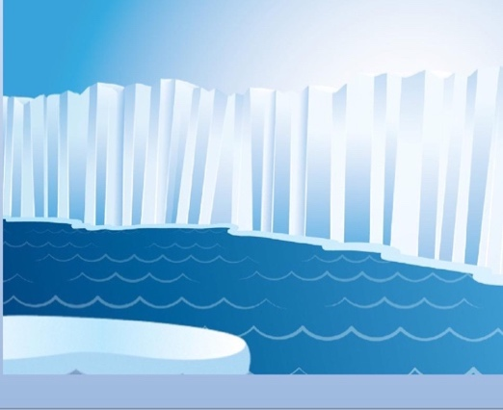
Fun Facts
- The Arctic region is found in the northernmost part of Earth.
- The name ‘Arctic’ comes from a Greek word meaning ‘near the bear’.
- The coldest recorded temperature in the Arctic is around −68 °C (−90 °F).
- A number of different types of animals make their home in the arctic.
- The Arctic region is home to the North Pole.
- The Arctic has a number of natural resources, including fish, oil, gas and various minerals.
- The Arctic is almost entirely covered by water, much of it frozen.
Animals: penguins, arctic wolf, caribou, dall sheep, penguins. Seals polar bears, walrus, puffins
Plants: Small shrubs, mosses, lichens, herbs (grow in warmer parts of the Arctic)

