STEAM Cooking Activities
Here are two fun cooking activities for the family. Make sure you have the supervision of an adult or older sibling. Enjoy!

Microwave Chocolate Mug Cake
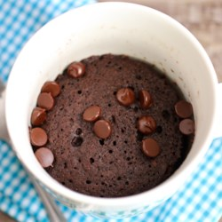
Prep: 5 min. Cook: 2 min. Ready: 7 min.
Recipe by: safinabakes1231
Practice your measuring skills with this fun cooking activity.

Ingredients
- 1/4 cup all-purpose flour
- 1/4 cup white sugar
- 2 tablespoons unsweetened cocoa powder
- 1/8 teaspoon baking soda
- 1/8 teaspoon salt
- 3 tablespoons milk
- 2 tablespoons canola oil
- 1 tablespoon water
- 1/4 teaspoon vanilla extract

Directions
1. Mix flour, sugar, cocoa powder, baking soda, and salt in a large microwave-safe mug; stir in milk, canola oil, water, and vanilla extract.
2. Cook in microwave until cake is done in the middle, about 1 minute 45 seconds.
Add toppings (optional): ice cream, sprinkle, whipped cream, cake icing

Easy Fruit Salad
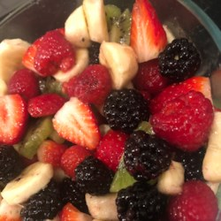
Prep: 10 min. Ready: In 10 min.
Recipe by: khammond87
Easy fruit salad in just minutes. Add whatever fruit you want to mix it up.

Ingredients
- 2 bananas, cut into bite-size pieces
- 2 apples, cut into bite-size pieces
- 2 (15 ounce) cans mandarin oranges, drained
- 1 (8 ounce) container frozen whipped topping (such as Cool Whip), thawed

Directions
1. Mix bananas, apples, and mandarin orange segments together in a bowl
2. Add whipped topping and stir gently to coat fruit with whipped topping. Refrigerate unserved portions.

