Clue  *  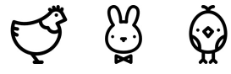 | Clue  *
Clue  * | Clue  *

