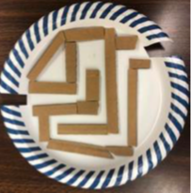 | A-maze-ing  Maze  STEAM  Challenge | 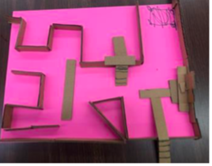
A maze is a network of paths. Mazes are usually designed as a puzzle through which something has to find their way. Most mazes also have a start and a finish.
The Design Process
 | Can you design, build, and test a maze that acts as a network of paths for a marble to move from the start to the finish?
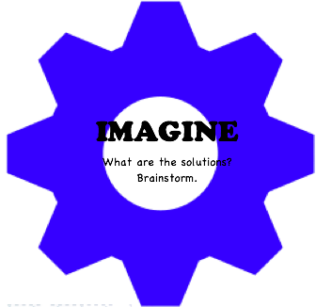 | After learning about mazes, imagine a maze that provides a network of paths for a marble.
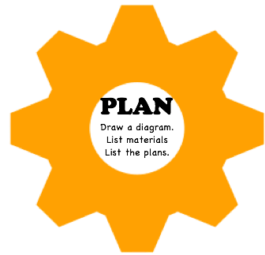 | Draw your plan directly on the base.  You will need:  A marble or very small ball, scissors  For the base: a cardboard box, shoe box, paper plate, poster board, Lego board (choose one)  For the dividers: folded paper, strips of cardboard, straws, Lego blocks, connecting blocks (choose one)  For the adhesive: glue, glue sticks, tape
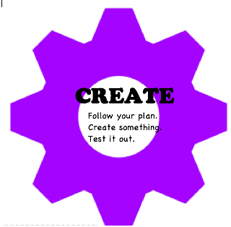 | Using the materials provided and your plan, construct your maze. Your maze should include a start and a finish and a square, rectangle and triangle.  Once your maze is constructed, carefully test it with your marble and see if acts properly as a network for paths. Observe and record how the marble responds.
 | Did your maze work? Can you improve it? Evaluate. Makes corrections if necessary. Share your invention with a friend. Ask friends for comments and suggestions.

Ask a family member or a friend to help you capture maze in motion. Send your video via e-mail to me.

